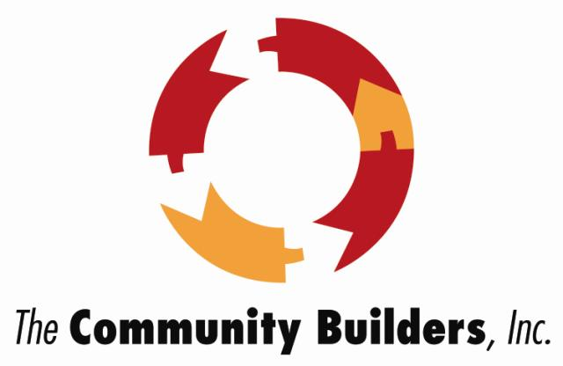
Job Title: _________General Counsel_____________
Report To: ________ __President and CEO_________
Department: _________Corporate Legal___________
FLSA Code: _____________Exempt _______________
Job Code: _____________ ______________________
Date Modified: __________10/2018_______________

The Community Builders, Inc. (TCB) is a nationally recognized nonprofit developer, owner, and manager of affordable and mixed-income housing and commercial properties. Founded in 1964, TCB has developed over 29,000 housing units as well as office and retail properties and owns and manages over 10,000 units of housing. TCB is currently active in Massachusetts, Connecticut, Rhode Island, New York, New Jersey, Pennsylvania, Maryland, Virginia, North Carolina, Illinois, Indiana, Michigan, Ohio, Kentucky, and the District of Columbia. TCB’s mission is to build and sustain strong communities where people of all incomes can fulfill their full potential.

TCB’s Legal Department, which is situated in our Boston office, manages all aspects of TCB’s corporate and transactional legal work, and currently consists of 5 attorneys, a senior paralegal, a paralegal/administrative assistant and, from time to time, student interns or clerks. We act as transactional counsel with respect to complex development and preservation transactions and, on some projects, engage and oversee outside counsel, form and maintain more than 500 affiliated entities, provide or manage all corporate legal services, and provide counsel on legislative and policy matters.

The General Counsel will lead the Legal Department and will be a member TCB’s senior leadership team. Specific responsibilities of the General Counsel are expected to include some or all of the following:

Essential Functions:

- Corporate Representation. The General Counsel advises the President/CEO and Board of Directors on all legal matters and provides strategic counsel on business and operational decisions. The General Counsel’s office provides legal representation to TCB and its affiliates on diverse matters, TCB’s corporate structure, its capital and lending relationships, its 501(c)(3) status, and the formation and maintenance of approximately 500 subsidiaries and affiliates (including business and nonprofit corporations, partnerships and LLCs) in various states. The General Counsel manages and coordinates the work of external law firms as needed. We also provide advice on employment discrimination, fair housing and other occupancy related matters, and general contracts. The office is also responsible for tracking and managing third-party claims, which primarily consists of and engaging and supervising outside counsel in connection with litigation, defaults, compliance matters, employment matters, fair housing and other legal matters.
- Transactional Practice. The General Counsel’s office represents TCB and its affiliates in the acquisition, development, construction, financing, operation, compliance and disposition of affordable and mixed income residential and commercial properties. TCB lawyers staff some projects directly (particularly in Massachusetts) and in other projects supervise outside counsel, who may have a range of roles ranging from advice on a specific issue to primary responsibility for the closing process. Our practice includes all aspects of real estate and housing development, including tax and financial structuring, title and real estate conveyancing, zoning analysis and relief, review of environmental matters, organization of ownership entities including nonprofit and for-profit corporations, LLCs and limited partnerships, and negotiating and closing complex financings involving multiple private and public funding sources.
- Funding Program Counsel. The General Counsel’s office provides counsel in connection with various grant and funding programs that TCB and its affiliates participate in, currently including the Neighborhood Stabilization Program, the Capital Magnet Fund, Choice Neighborhoods Implementation Grant, the New Markets Tax Credit Program, and various foundation and other grants and program-related investments. The General Counsel may be asked to provide and/or oversee legal services related to these programs, including due diligence, documentation and closing of loan transactions on behalf of lender, development and maintenance of internal controls and counsel with respect to program requirements.
- Compliance and Management. We provide counsel on all aspects of regulatory and legal compliance and legal aspects of the operation and management of affordable and mixed-income housing communities and the provision of services to residents. The General Counsel also advises on the development and implementation of corporate and compliance policies, forms, systems, and tools to ensure the effective management of legal and other operating risks. The General Counsel also assists other departments on creating and presenting training on relevant legal topics.
- Legislative and Policy Matters. The General Counsel is a member of TCB’s internal public policy committee and from time to time assists in legislative and policy matters.
- Department Administration. The General Counsel is responsible for administration of the Legal Department, including supervision and training of all staff, development and implementation of procedures and form documents, and managing the department’s budget, billing, collections and vendors.

Education & Experience:

- Excellent academic record;
- 10-15 years’ relevant professional experience including time as a practicing corporate and/or transactional attorney, with demonstrated ability to manage complex engagements in a team environment;
- Substantial experience with most or all of the following -- affordable housing and community development finance, LIHTC, NMTC and other tax credits, real estate, zoning and permitting, construction contracts, nonprofit organizations, fair housing, general corporate and employment law;
- Admission to state bar;
- Experience working in a complex organization, and creating and implementing policies and procedures for organizational development; and
- Demonstrated commitment to affordable housing and community development or related mission-oriented work.

Knowledge, Skills and Abilities:

- Ability to analyze and solve complex legal problems;
- Excellent writing and communication skills;
- Effective legal and business judgment in challenging situations;
- Demonstrated ability to be effective in a complex organization;
- Collaborative and respectful management style; and
- Innovative and creative thinker and problem solver.

The Community Builders, Inc. is committed to ensuring diversity in its workplace, and candidates from diverse backgrounds are strongly encouraged to apply.

For more information about TCB and to apply, please http://www.tcbinc.org/2015-10-15-16-47-38.html.

