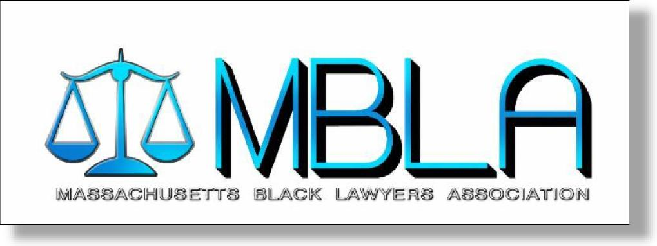
Massachusetts Black Lawyers Association
Elections Information Packet
May 2021 - April 2022

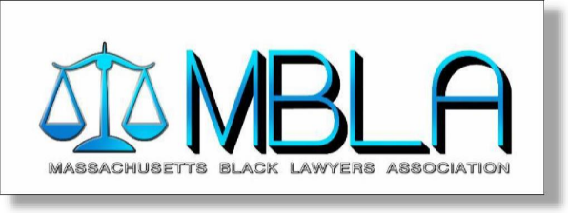

Dear MBLA Member:
On Tuesday, May 11, 2021 at 6 p.m., the MBLA will elect officers and directors to serve during the coming year. I hope that you will consider running for office. Your skill and excitement are what make this organization great. If you can make a year-long commitment to lead, we want you to be a candidate. All active members of the MBLA who are members in good standing of the Massachusetts Bar are eligible to run for elected office. “Elected office” includes the positions of President-Elect, Executive Vice-president, Treasurer, Secretary, & At-Large Director.
In addition to electing officers and directors, the MBLA is in the process of forming committees to support the board in its work. Becoming a committee member is a great way to get more involved and a tremendous networking opportunity. If you have any interest in joining a committee, please complete an application and we will find a role for you. Law students are also welcome, and encouraged, to serve on committees!
This packet contains:
- An invitation to the 47th MBLA Annual Meeting and Election
- A description of officer positions as set forth in the MBLA by-laws;
- A description of the committees that help the board run the MBLA;
- A candidate application for elected office; and
- An application for committee membership;
Completed applications for elected office should be submitted via email to president@mablacklawyers.org and presidentelect@mablacklawyers.org no later than 5 p.m. on Monday, May 3, 2020. Please note that late applications for elected positions may not be considered.
Applications for committee membership should be submitted as soon as possible because committees will begin work in May.
Thank you for considering a role in leadership with the MBLA. Please do not hesitate to contact me at presidentelect@massblacklawyers.org for more information.

Best,

Asha White
President-Elect 2020-2021
presidentelect@mablacklawyers.org

MBLA Annual Meeting and Election

May 11, 2021
6 p.m.

Boston Bar Association
16 Beacon Street, Boston, MA

- During an Annual Meeting on May 11, 2021 at 6pm, MBLA members will elect directors and corporate officers for the 2021-2022 administrative year. To RSVP for the Annual Meeting please visit www.mablacklawyers.org. This event will take place virtually.

- To vote in this election, you must be a current member of the MBLA. MBLA membership expires each year on March 31. Please renew your membership before the annual meeting to be eligible to vote.

- Candidates for elected office must be (i) current members of the MBLA, and (ii) admitted in good standing to the Massachusetts Bar and membership to any State or Federal bar. Applications must be submitted to presidentelect@mablacklawyers.org AND president@mablacklawyers.org by 5 p.m. EST on Monday, May 3, 2021. Candidates are encouraged to submit their materials as early as possible.

New Officer & Director Retreat
Orientation for the 2021-2022 MBLA Board of Directors will be held on Sunday, June 6, 2021. Candidates should plan to be available to attend if elected. Currently, MBLA plans to hold this event in person.
Monthly Board of Directors Meetings
The board of directors will meet on the second Wednesday of each month at 6:30 p.m. at the Boston Bar Association. Candidates should be prepared to attend each month if elected. All active members are invited to attend board meetings. Dinner is provided.

PLEASE NOTE: Pursuant to Mass. Gen. Laws Ch. 180, §6D, the MBLA is required to complete a certification of Change of Directors or Officers of Non-Profit Corporations which includes each elected individual’s name and residential address. The MBLA will use the information in your completed application to update our records. Should you have any questions or concerns, please do not hesitate to contact Asha White.
DESCRIPTION OF OFFICER POSITIONS
President
"The President shall be the chief executive officer of the corporation and shall, subject to the direction of the Board of Directors, have general supervision and control of the corporation, and shall perform all duties delegated to him or her by law, the Articles of Organization, these Bylaws and the Board of Directors. The President shall preside over meetings of the members of the corporation and the Board of Directors and shall be an ex officio member of all committees of the corporation." Art. VI, sec. 6.5
President-Elect
"The President-Elect shall serve in the absence or inability of the President to act. The President-Elect shall perform such duties as the President and Board of Directors may assign." Art. VI, sec. 6.6
Executive Vice President
"The Executive Vice President shall perform such duties as the President and the Board of Directors may assign." Art. VI, sec. 6.7
Treasurer
"The Treasurer shall, subject to the direction of the Board of Directors, have general charge of the financial affairs of the corporation and shall cause to be kept accurate books of account. The Treasurer shall further report on the financial condition of the corporation at all regular meetings of the Board of Directors. The Treasurer shall have custody of all funds, securities and valuable documents and shall arrange for an annual financial audit of the books of account." Art. VI, sec. 6.8
Secretary
"The Secretary shall be the principal recording officer of the corporation. The Secretary shall record all proceedings of the members and discharge all duties incident to the office. Any Assistant Secretary shall perform such of the duties of the Secretary and such other duties as the Board of Directors, the President or the Secretary may designate." Art. VI, sec. 6.9
At-Large Director
"The corporation shall have a board consisting of directors who shall have the powers and duties of a board of directors under Massachusetts law. The directors shall be responsible for the general management and supervision of the business and affairs of the corporation, except with respect to those powers reserved to the members by law, the Articles of Organization or these Bylaws." Art. V, sec 5.1
Directors are expected to attend monthly board meetings. Directors are also asked to assume leadership responsibility with respect to at least one committee for the length of the board term.

DESCRIPTION OF BOARD COMMITTEES
Finance
This committee ensures compliance with applicable state and federal laws and maintains the organization’s tax-exempt status. This Committee is chaired by the Treasurer of the organization. Committee membership is predetermined by organizational policy.
Community Service
This committee encourages the involvement of the membership in volunteer legal services and community service activities. Annual programs of the Community Service Committee include MLK Day of Service, Know Your Rights and MBLA Reads.
Programs and Professional Development
This committee is responsible for planning and executing programs geared to enhance the retention and advancement of attorneys of color in Massachusetts.
Black Women in the Profession Sub-Committee
This sub-committee of the Programs and Professional Development Committee will work with the Professional Development Committee and external organizations to ensure Black women attorneys and law students have equal opportunities for professional growth and development in the Commonwealth. More specifically, this Committee will work to address the decline of Black female representation among law firm associate and partner ranks, both locally and nationally.
Student Support
This committee oversees the MBLA’s pipeline initiatives and provides support to area law school students, including scholarships and awards. Annual Programs of the Student Support Committee include the Fall Student Reception and the BLSA Presidents’ Mixer. This committee also coordinates the Hon. Roderick L. Ireland Leadership and Juvenile Advocacy and the Hon. Reginald Lindsay Public Service Scholarship Awards.
Membership Development
This committee is responsible for the development of the organization’s membership. Annual programs of the Membership Development Committee include the Fall Reception and the Pre-Gala Mixer. This committee is further responsible for elevating the profiles of our membership through nominations to local and national awards.

Judicial Appointment
This committee helps identify and encourage lawyers to apply for judicial vacancies. Annual programs of the Judicial Appointment Committee include the Judicial Application Nuts & Bolts program.
External Affairs
This committee will facilitate MBLA partnerships with other similarly-missioned organizations locally, regionally, nationally and internationally. It will work to improve the state-wide awareness of the MBLA through media, strategic collaborations with external organizations, and other appropriate mechanisms. Finally, it will advise the MBLA Board of Directors, its Committees and partners and coordinate their external communication efforts on important current MBLA initiatives, programs and policy positions, if any.
Social Action
This committee encourages leadership, advocacy and empowerment of the MBLA membership and greater legal community to effect social change and public policy in the Commonwealth. Through this Committee, the MBLA hopes to establish its position on emerging or perennial public issues pertinent to the practice of law in the Commonwealth. The committee will implement programs that stimulate social action and educate members and the community on current social justice issues.
Webmaster
The Webmaster will be responsible for facilitating and/or coordinating all website maintenance. He or she will work closely with the MBLA web-developer(s) to debug issues that arise with the performance of the website, interface the website for performance issues and manage website advertisements. The Webmaster will also review website statistics and monitor analytics, as appropriate, work to maintain web design that is up-to-date and responsive and plan for future site improvements.

LGBTQ+

This committee encourages collaboration and advocacy amongst the LGBTQ+ legal community to continue to promote, broaden and strengthen diversity throughout the Commonwealth. This committee is responsible for annual programs geared towards providing resources, education, safe spaces and collaboration with affiliated organizations to increase visibility.

CANDIDATE APPLICATION
2021-2022 MBLA Officers and Directors
Submission Deadline: Monday, May 3, 2021 (5 p.m. EST)
Name
Mailing Address
Email |  |  |  | Phone
Law School |  |  |  | Year of Graduation
Year Admitted to MA Bar (If Applicable) |  |  |  | Years of Practice
Academic Credentials
Honors and Awards
Non-Profit Board Service

Position to which you seek election: (Choose only one)

- President-Elect | - Executive Vice President | - Treasurer
- Secretary | - At-Large Director
Expression of Interest:

By signing below, I express my willingness to serve in the position indicated above if elected.

________________________________________
Signature
Additional Materials:
- Curriculum Vitae (Resume) | - High Quality Headshot of Candidate
Candidate Statement:
Please provide a narrative statement of 200 words or less in support of your candidacy for elected office. The statement should describe your biographical background. Additional questions you might answer in your statement include:
- How has the MBLA impacted you personally or professionally?
- If elected or appointed, what goals would you set for yourself? What objectives would you hope to accomplish?
- What roles have you played with the MBLA? How has your service to the MBLA prepared you for the leadership position you now seek?
- In your opinion, what are the most pressing needs of Black attorneys and law students in the Commonwealth of Massachusetts? How can the MBLA best address those needs?

COMMITTEE APPLICATION
2021-2022 MBLA Term

Name
Mailing Address
Email |  |  |  | Phone
Law School |  |  |  | Year of Graduation
Year Admitted to MA Bar (If applicable) |  |  |  | Years of Practice (If applicable)
Academic Credentials
Honors and Awards
Non-Profit Board Service

Applicant Statement:
Please provide a narrative statement of describing your biographical background, as well as your interest in serving on an MBLA committee. This is your chance to tell us what excites you and what you are good at. We will use your statement to find a role for you that uses your talents and helps you make connections that matter for you. Additional questions you might answer in your statement include:
- How has the MBLA impacted you personally or professionally?
- In serving on a committee, what goals would you set for yourself? What objectives would you hope to accomplish?
- What roles have you played with the MBLA? How has your service to the MBLA prepared you for the leadership position you now seek?
- In your opinion, what are the most pressing needs of Black attorneys and law students in the Commonwealth of Massachusetts? How can the MBLA best address those needs?

