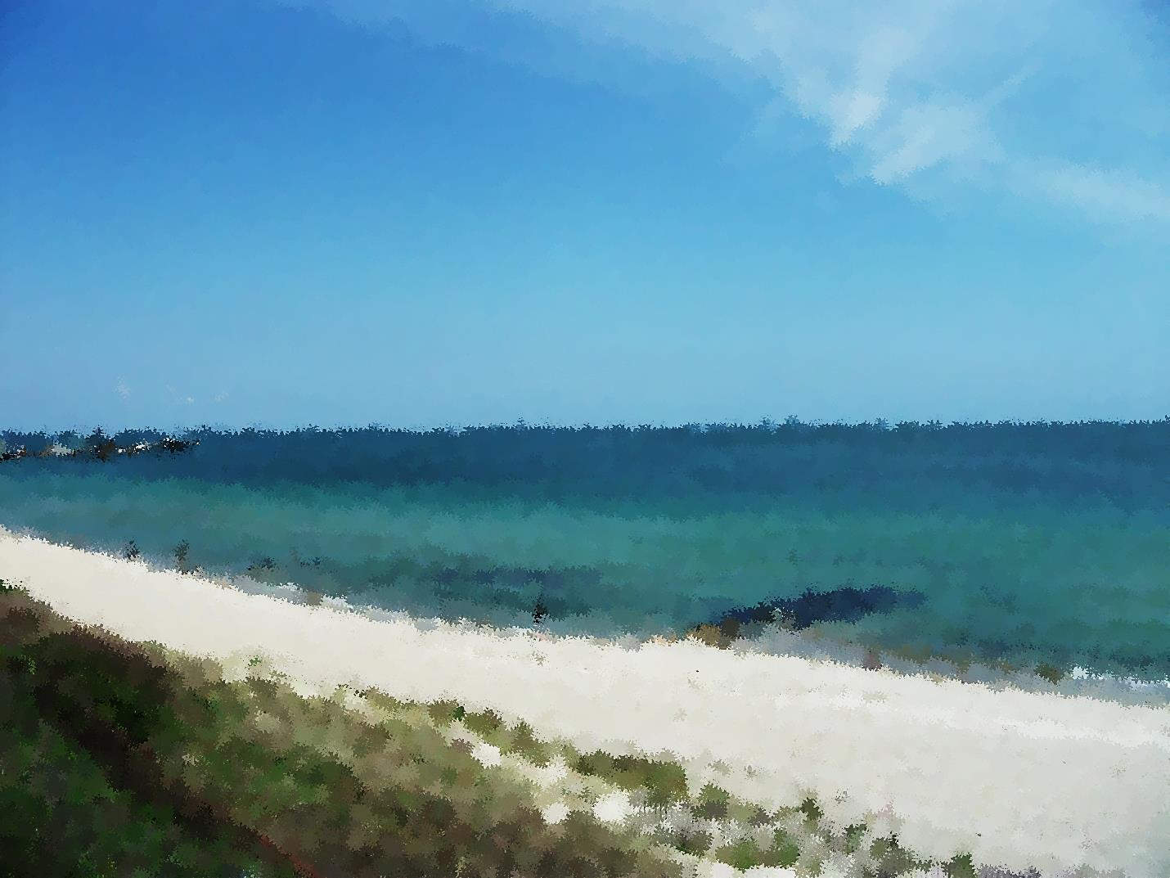
.
Massachusetts Black Lawyers Association
5th Annual Summer Clambake
August 2, 2014
Oak Bluffs, Martha’s Vineyard

Schedule of Events
12:00-12:30 Check in at Waban Park, Oak Bluffs
12:30-2:00 Heritage Tour ($25 per person)
2:00-5:00 Free Time/activities at the Ink Well
5:00-5:45 Registration and Clambake Reception
5:45-8:00 Clambake Dinner

Heritage Tour
Come and enjoy a personalized tour of the Vineyard, with an emphasis on African American culture and historical landmarks. Cost is $25 per person.
Clambake
Join us for an evening of great food and great company. The Clambake Dinner will include clam chowder, lobster, mussels, steamers, Italian sausage, sweet potatoes, corn on the cob, red potatoes, pearl onions, barbeque chicken, and dessert. Cost is $60 for members and $80 for non-members.

The children’s menu will include clam chowder, hot dogs, hamburgers and cheeseburgers, corn on the cob, chips, and dessert. Cost is $25 for children 12 and under. Lobster is not included.

Tickets are available for purchase online http://www.brownpapertickets.com/event/720469
*Ferry transportation to and from Oak Bluffs is included in ticket price. However, to receive a ferry ticket, you must select this option when you make your purchase.
* Limited round trip bus transportation is available to/from downtown Boston and is not included in the clambake ticket price. Transportation cost is $20 per person.
*Tickets are non-refundable.
*Event will take place rain or shine.

